**CSS(Cascading Style Sheets)**

1. In css we have to give the value to the property and the property are of two types
   1. Defined
   2. PreDefined
2. Property can be anything like colour, font-family, text-align, etc
3. There are three ways to add CSS in the html
4. Inline
5. Internal
6. External
   1. **Inline**

<tagName style=”property:value,”>

Eg. <h1 style=”color : blueviolet”, >Welcome to css</h1>

*color not colour

* 1. **Internal**

<html>

<head>

<title>Hello</title>

<style>

h2{

color : brown;

}

</style>

</head>

<body>

<h1>You are in h1</h1>

<h2> You are in h2</h2>

<h3> You are in h3</h3>

</body>

</html>

* 1. **External**

In html : <link rel=”stylesheet” href=”style.css”>

In style.css:

h1{

color : blue;

}

h2{

color : red;

}

🡪In external way there are many selectors :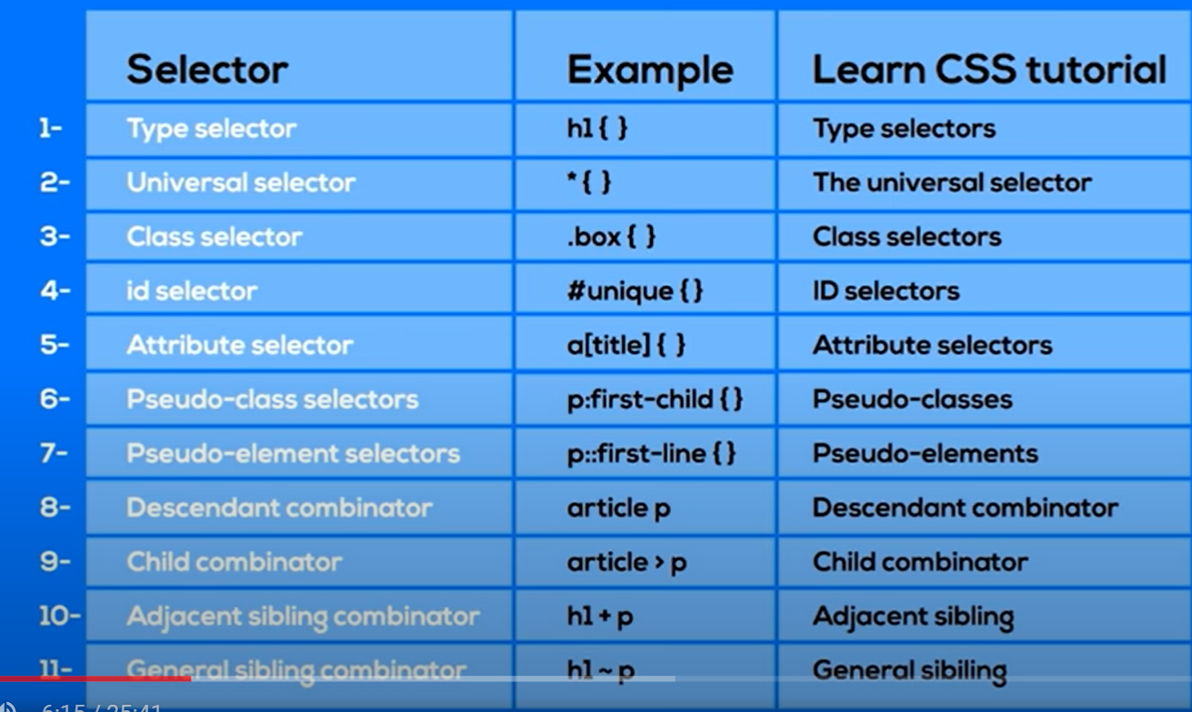

🡪The common syntax for css is :



🡪Some example of different selectors :

🡪Combined Selectors

h1,p,span{

color : purple;

}

🡪Class Selectors

.className{

Property : value;

}

🡪Id selectors

#idName{

Property: value;

}

1. For getting the colour in the background we use :

Background color :<colour name>;

1. For getting the image in the background we use :

Background-image : url(“image.jpg”);

1. We can perform many actions to the text and background and many other things by writing the name and then after the suggestions will come automatically :

background-

text-

1. For finding the different properties of any thing hover around the main thing and due to that the slide will come and in it click on MDN Reference for getting more about its uses
2. For getting the font to be bold, we have to use font-weight : bold;
3. In css there are two types of units :
   1. Relative

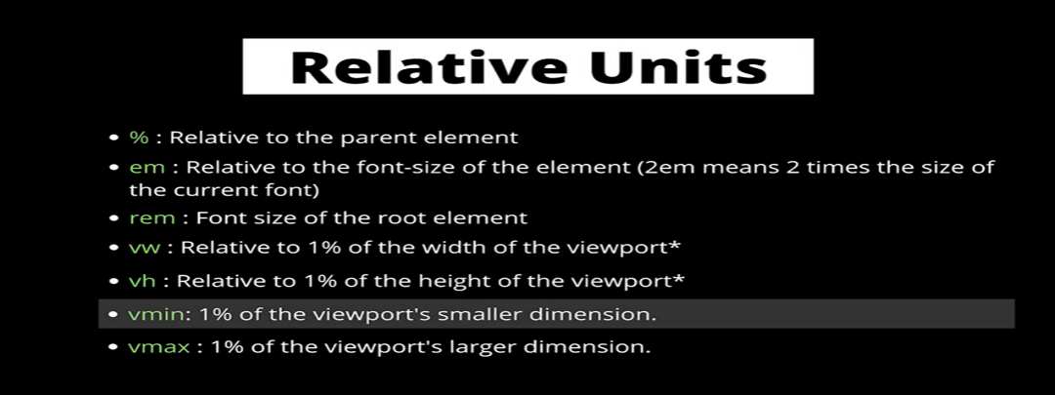

* 1. Absolute

cm, mm, in, px, pt, pc

1. Box Model

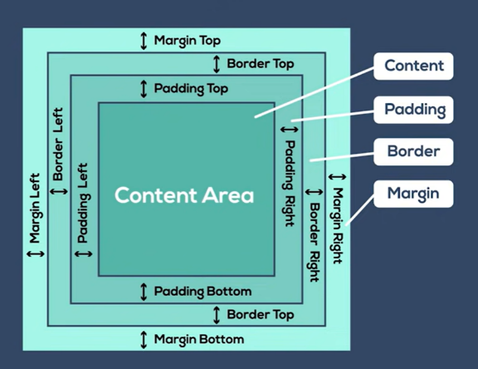

🡪The background colour is not included in the margin space, it is only limited to the padding space

🡪But the colour of the margin is same that of the colour of the page background or the component background

1. List-style-type 🡪To make change in the symbol of the bullets

Example :

list-style-type : square;

list-style-type : round, etc.

1. List-style-position 🡪To make the background of the points

🡪It is of the two types :

* + 1. list-style-popsition : outside;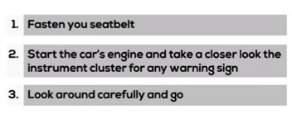 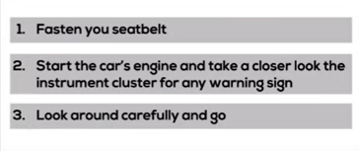

**2**

**1**

* + 1. list-style-position : inside;

1. For making the border of the any component to be viewed, we have to add the attribute solid in the tag compulsory otherwise the border will not be seen
2. To remove all the special effect of the link we have to make the :

text-decoration : none;

1. For making the box or text to go anywhere in the page, we can make use of the float :

Eg. @media all and (max-width : 450px) and (min-width : 250px){

.a{

Float left;

Padding : 80px;

Background-color : blue;

}

}

1. The float can be made right, left, none, etc
2. For changing any property of the single thing in css we have to make an class or id for it :

In Body :

Eg. <li class=”class1”>Inherited</li><a href=”#”>Click Here</a>

In style :

<style>

.class1 a{

text-color : pink;

}

</style>

1. For changing the colour while hovering the mouse over the element the following code will be used :

nav a:hover

{

    color: aqua;

}

1. When we give the different effect to the same class or element than the effect which is at the last will be implemented instead of the first one
2. The specificity of the class, id, !important and the simple tag is as follow :

h1 < .heading < #heading < !important

🡪Where the !important is the special key word and it has the highest specificity than any other keyword and it is very risky as because of it the css of the whole page can also be destroyed, so use it carefully

🡪The specificity of the inline css is more than the internal or external css but there is an exception of the !important keyword

1. The overflow in the css is called when there is the small size of the component as compared to the content and the content goes out of the component and there are the various properties in the css to stop this overflow by adding the following code into the style tag :

overflow : auto;

*here instead of the auto various other things can be added like hidden, scroll, visible, etc.

1. Overflow also occurs in the images and to stop it the object-fit method is used inside the style tag of that compartment or section, the code can be written as:

object-fit : contain

*here instead of the auto various other things can be added like cover, fill,scale-down etc.

🡪This happens while controlling the image with help of the height and width and if we set only one of them then the image ratio is maintained

1. For making the website customize to the screen width we use the @media annotation in the css file or by adding the <style>…</style>in the head section of the html file
2. *Here instead of the screen we can also write the all, print they are called as media types

🡪Example in the head section of the body

<style>

@media screen and(max-width : 600px){

color : red;

}

</style>

🡪Example with the two and condition

<style>

@media screen and(max-width : 600px), screen and (orientation : landscape){

body{ color : blue;

}

}

</style>

🡪Example of the not operator

<style>

@media not all and (orientation : landscape){

body{

color : blue;

}

}

</style>

🡪The example of making the change in the unordered having the li tag

<style>

@media all and (max-width: 1000px) and (min-width: 700px){

#sidebar ul li a:before{

content : “Email: ”;

font-style : italic;

color : #666;

}

}

</style>

*instead of the before we can also use after

1. Types of the media types :
   1. All
   2. Print
   3. Screen

Types of the logical operators :

1. and
2. This is the list of the currently valid css features :
   1. any-hover
   2. any-pointer
   3. aspect-ratio
   4. color
3. not
4. only
   1. color-gamut
   2. color-index
   3. dynamic-range
   4. grid
   5. height
   6. hover

Logical Operator

* 1. overflow-block

@media all and (max-width : 500px)

* 1. pointer

Css features

Media Type

* 1. resolution
  2. width

1. Do download the .png image as they do not have the background
2. To make any text or thing to not follow the float, we can use the clear in css in .css file or style tag

Eg. .cleared{

clear : left;

}

*We can use the right, left, none etc..

1. For making the navabar sticky in the website, we have add the position in the style of the website and this can be made when there is the child div’s inside the parent div and we have to add this code in the parent’s div

.box{

Position : sticky;

}

1. By the help of the flex we can make the box or components of the container to be align in the one line instead of the arrangement in which they are in the line

Eg. display : flex;

1. Further we can perform many task after selecting the diplay as flex some of them are :

Flex-direction

-wrap

-grow

-shrink

-flow, etc

🡪some important one of the mainly use are :

* + 1. (IMP)flex-wrap: wrap; 🡪To make the box to move down when page limit is over
    2. align-content: center 🡪To make the content to be aligned in central
    3. align-content: stretch 🡪To make the content stretch to whole page
    4. flex-grow : 2 🡪To make the content to grow compare to others
    5. flex-shrink : 2 🡪To make the content to shrink compare to others

1. The animation in the css can be done by the two ways:
   1. Transition Property
   2. Animation Property
2. The format of the transition property which is used for animation is :

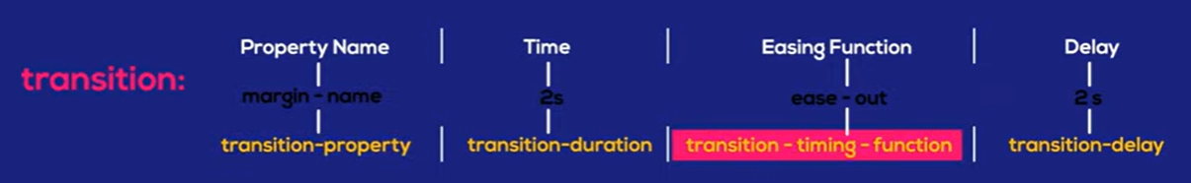

1. For animation propery :

@keyframes name_of_animation{

0%{

font-size: 10px;

}

50%{

font-size: 20px;

}

100%{

font-size: 30px;

}

}

div{

animation: name_of_animation 2s infinite;

}

1. or making the time in transition of objects we have to add the transition: <the property to be changed> 2s
2. For making any thing change on hover, the hover property can br used by this way :

.<class-name>{

Width: 100px; transition: width 2s;

}

.<class-name>:hover{

<properties to change here>

}

1. The main sub properties in animation are :
   1. animation-name: name_of_animation;
   2. animation-duration: 750ms;
   3. animation-timing-function: linear;
   4. animation-delay: 250ms;
   5. animation-iteration-count: 2 or infinite;
   6. animation-direction: reverse;
   7. animation-fill-mode: forward;
   8. animation-play-state: paused or paused;

*Here the term after the ‘:’ can be replaced by the other and selection can be made by the list of the IDE

<head>

    <meta charset="UTF-8">

    <meta http-equiv="X-UA-Compatible" content="IE=edge">

    <meta name="viewport" content="width=device-width, initial-scale=1.0">

    <title>Document</title>

    <style>

        a{

            animation: bouncing 0.5s ease 0s infinite alternate both;

            background-color: blue;

            border-radius: 50%;

            display: inline-block;

            color: white;

            padding: 1em 2em 1.1em;

            position: relative;

            margin-top: 100px;

        }

        @keyframes bouncing {

            0%{

                bottom: 0;

                box-shadow: 0 0 5px rgba(0, 0, 0, 0.5);

            }

            100%{

                bottom: 50px;

                box-shadow: 0 50px 50px rgba(0, 0, 0, 0.1);

            }

        }

    </style>

</head>

<body>

    <a>LOADING</a>

</body>

1. For making the css properties to all the elements present, we represent it by :

*{

Box-sizing: border-box;

}

1. In every website the some of the margin is given and it can be removed by making the margin: 0px in the body tag
2. Nav bar css code :

nav{

background-color: #333;

overflow: hidden;

}

nav a{

display: block;

color: white;

text-decoration: none;

padding 14px 20px;

float: left;

}

1. For making the text to align in the center, we have to make the <section>…</section> and in which all data should be taken and in it :

section{

text-align: center;

}

1. For making the nth section different by color :

section:nth-child(even){

background-color: red;

}

1. For making the icon of the website which is made to be seen in the browser :

Chrome🡪favicon.io🡪png->ICO🡪Drag and drop🡪Download🡪Copy the following link tags given and paste it into the head tag🡪Change path in the link given by default

1. In css we handle the .gif as the image only

🡪For it we have to make an div tag and make it class=banner

🡪In .css file

.banner{

background-image: url(../assets/logo/logo.gif);

Height : 20vw;

min-height: 100px;

background-repeat: no-repeat;

background-position: top center;

background-size: 50%;

}

1. For making the banner fixed at the one position :

background-attachment: fixed;

1. For changing the color of the background we have to use the background-color: but for changing the color of the text we have to use the color:
2. (I.M.P.) For making the gallery like structure having the button to move it and in which we can put the videos or the images we use the external plugin which is known as the **carousel**

🡪There are many plugins available online but we have used the plugin of the flickity, which is not free for the commercial purpose, so try another one also

🡪In this we have to add the css path in the head and the js part in the ending of the body tag, we also have to add the code by making the .css file and ….

1. To make the icon in the website we have to write icon in html🡪then go to any website🡪use font awesome 4 icons🡪copy the link given in the template🡪go to google search font awesome <any-website-name> icon🡪go to fontawsome.com(Always select the 2nd link in which there is the black icon)🡪then copy the given link given in it which has the <i> tag
2. For making the link we have to make use of the <a> tag with the href
3. For finding the colour of the logo we have to write the name of the company and then write the logo colour in the google
4. In jsx we can give the style to the tag by, example

**<img src=”map_image.png” style={{width: ‘100%’}}></img>**

1. In the jsx, there are some difference in the style class where there is – in between the name example font-family, so it would give error in the JSX, instead of it we can use the following :

**<h1 className=’pt-3’ style={{fontFamily: ‘Georgia’}}>About US</h1>**